

Submission for Mobile App Development Group Assessment

# **Title for your project.**

“COVInfo”

# **Your group number.**

Group 5.

# **URL of your application:**

[Our application URL.](https://devweb2020.cis.strath.ac.uk/~fmb18174/hoqpwjkciguaelk/)

# **URL of the GitLab repository:**

[Our Gitlab repository.](https://gitlab.cis.strath.ac.uk/cs317-2020/mad-group-05)

**List any substantial code copied from outside sources.**

Apart from using Material Design Bootstrap .css and .js files, we have not used any code from external sources.

*By making this submission we confirm that the project code was developed fully by members of the team and no substantial code apart from that listed above has been copied. We understand that the code may be submitted for plagiarism detection.*

# **Describe the idea and motivation for your project.**

We wanted to provide an easy and visually attractive way for people to access information about COVID-19, be it information, up-to-date statistics or the latest news. Right now, while it is possible to find accurate statistics and information about COVID-19, it is unorganized and all over the web. Our app aims to provide a single, cohesive place for everything COVID-related. Our aim was to make sure that the user would not have to leave our app to find out anything related to the coronavirus pandemic. We also thought it was important for users to enjoy using our app on a wide variety of devices, so we made sure to make our app responsive in order for it to work on both mobile phone screens, as well as larger screens such as tablets.

# **Describe your target audience**.

* *Age group:* 18-35 (young adults).
* *Location:* United Kingdom,
* *Language:* English,
* *Interests:*
  + Staying up to date and engaging with the news.
  + Learning about new topics and new information about topics they already know.
  + Being conscious about their and other’s safety during a pandemic.
  + Data and how it translates to the real world.

# **Describe the development environment that you used, including the base technology and any frameworks.**

For our app to run on as many devices as possible, we opted to develop the app in HTML, CSS and JavaScript. To make development easier, we used [Material Design Bootstrap](https://mdbootstrap.com/) and [JQuery](https://jquery.com/). We chose to only rely on a minimum number of external frameworks in order for our app to run as smoothly as possible, particularly on low-end and budget devices. For the development environment, we used IntelliJ IDEA, as it offers helpful features when debugging JavaScript code in particular and allows for quick deployment to a remote server.

# **Any information needed to run your app**

* Even though the prototype version of the app does not *require* users to grant location access, it is needed for the app to function properly. It is currently expected the user accepts location permissions.
* While the app works on any device with a web browser, an Android device (with a Chromium-based browser) is vastly preferred, as the app is optimized for this platform

# **Screenshots**



*A welcome screen guides new user through creating a profile and accepting permission.*

*The “For you” section shows profile information at a glance and organizes helpful information into categories.*

*“Statistics” shows the numbers for various COVID statistics nationwide, worldwide and the user’s area, if enabled.*

*The “News” page aggregates articles from trusted news-outlets from all over the UK and the world.*

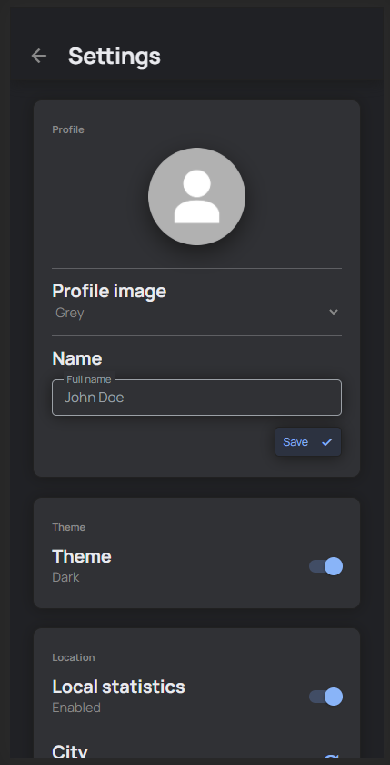

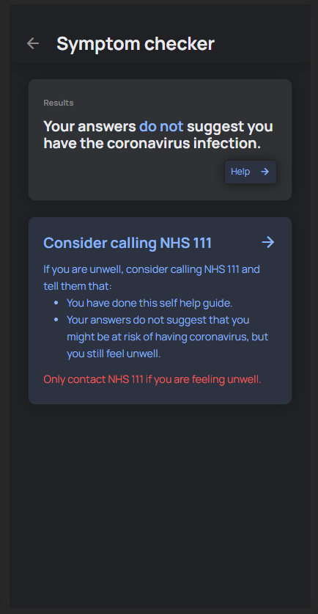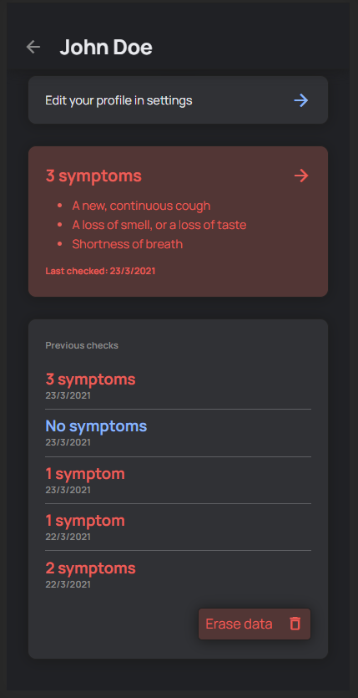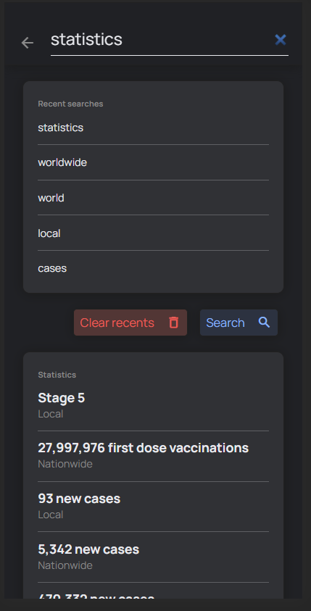

*A symptom checker allows the user to check whether they are at risk of having COVID-19 and guides them through what to do in case they are.*

*Through settings, the user can customize almost every aspect of the app – from changing their profile picture to toggling dark mode.*

*The user’s profile page keeps track of their last 5 symptom checks, allowing them to make informed decisions about whether to contact their doctor.*

*While using the search page, the user can quickly access and interact with information from across the entire app.*